Merge Sort and Quick Sort

NAME : MOHANAKUMAR S
REG NO :25BLC1057
SLOT : L9+L10
Q1) Write an algorithm for Merge Sort to sort the elements of an array in ascending order using the divide-and-conquer approach. Implement the algorithm in C language and verify its correctness using suitable sample input and output.
Algorithm: MergeSort(A, low, high)
Input: An array A containing n elements, where low and high are the starting and ending indices.
Output: The array sorted in ascending order.
Algorithm MergeSort(A, low, high)
Step 1: Check whether the array contains more than one element.
If low >= high, then
Return
End If
Step 2: Find the middle position.
mid = (low + high) / 2
Step 3: Divide the left half of the array.
Call MergeSort(A, low, mid)
Step 4: Divide the right half of the array.
Call MergeSort(A, mid + 1, high)
Step 5: Merge the two sorted halves.
Call Merge(A, low, mid, high)
Step 6: Return.
Algorithm: Merge(A, low, mid, high)
Purpose: Combines two sorted subarrays into one sorted array.
Left subarray: A[low ... mid]
Right subarray: A[mid+1 ... high]

Algorithm Merge(A, low, mid, high)
Step 1: Calculate the size of both subarrays.
n1 = mid - low + 1
n2 = high - mid
Step 2: Create two temporary arrays:
Left[n1]
Right[n2]
Step 3: Copy the elements from the left subarray into Left[].
Step 4: Copy the elements from the right subarray into Right[].
Step 5: Initialize three indices:
i = 0 // Index for Left[]
j = 0 // Index for Right[]
k = low // Index for original array
Step 6: Compare elements of Left[] and Right[].
While (i < n1) and (j < n2)
If Left[i] <= Right[j]
A[k] = Left[i]
i = i + 1
Else
A[k] = Right[j]
j = j + 1
End If
k = k + 1
End While
Step 7: Copy any remaining elements from Left[] into A[].
While i < n1
A[k] = Left[i]
i = i + 1
k = k + 1
End While

Step 8: Copy any remaining elements from Right[] into A[].
While j < n2
A[k] = Right[j]
j = j + 1
k = k + 1
End While
Step 9: Return.

C code:
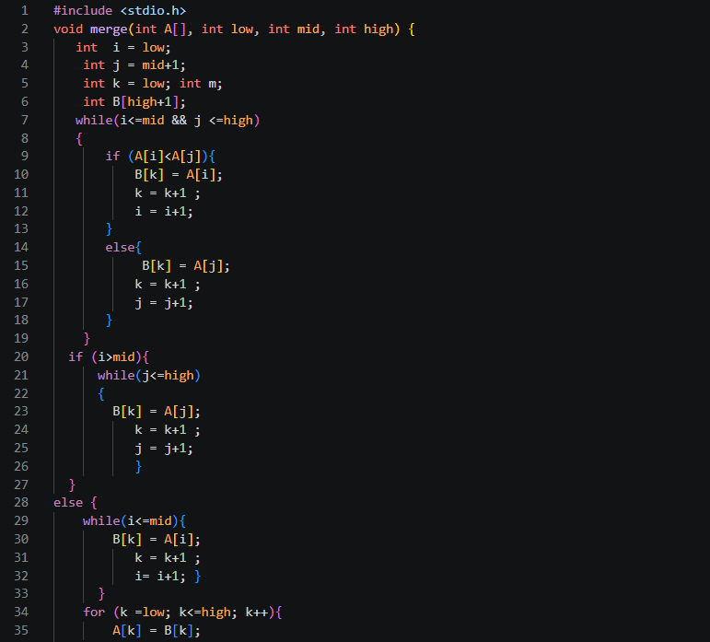
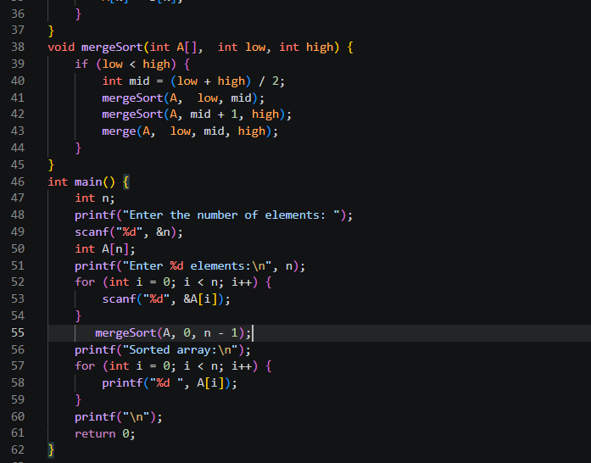
Output:
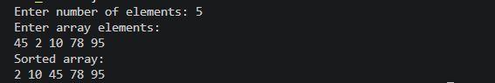

Q2) Write an algorithm for Quick Sort to sort the elements of an array in ascending order using the divide-and-conquer approach. Implement the algorithm in C language and verify its correctness using suitable sample input and output.
Quick Sort Algorithm
Algorithm: QuickSort(A, low, high)
Purpose: To sort the elements of an array in ascending order using the Divide and Conquer technique.
Input:
A [] – Array containing n elements
low – Starting index of the array
high – Ending index of the array
Output:
Sorted array in ascending order.
Algorithm QuickSort(A, low, high)
Step 1: Check whether the array contains more than one element.
If low >= high, then
Return
End If
Step 2: Partition the array around a pivot element.
pivotIndex = Partition(A, low, high)
Step 3: Recursively sort the left subarray.
Call QuickSort(A, low, pivotIndex - 1)
Step 4: Recursively sort the right subarray.
Call QuickSort(A, pivotIndex + 1, high)
Step 5: Return.

Algorithm: Partition(A, low, high)
Purpose: To place the pivot element in its correct sorted position by arranging:
Elements smaller than or equal to the pivot on the left.
Elements greater than the pivot on the right.
Assumption: The first element of the array is chosen as the pivot.
Algorithm Partition(A, low, high)
Step 1: Select the first element of the array as the pivot.
pivot = A[low]
Step 2: Initialize two pointers.
start = low
end = high
Step 3: Repeat the following steps while start < end.
Step 3.1:
Move the start pointer towards the right until an
element greater than the pivot is found.
while A[start] <= pivot do
start = start + 1
end while
Step 3.2:
Move the end pointer towards the left until an
element less than or equal to the pivot is found.
while A[end] > pivot do
end = end - 1
end while
Step 3.3:
If start < end, swap A[start] and A[end].
Step 4: After the pointers cross, swap the pivot
(A[low]) with A[end].
Step 5: Return the index end as the final position
of the pivot.

C code:
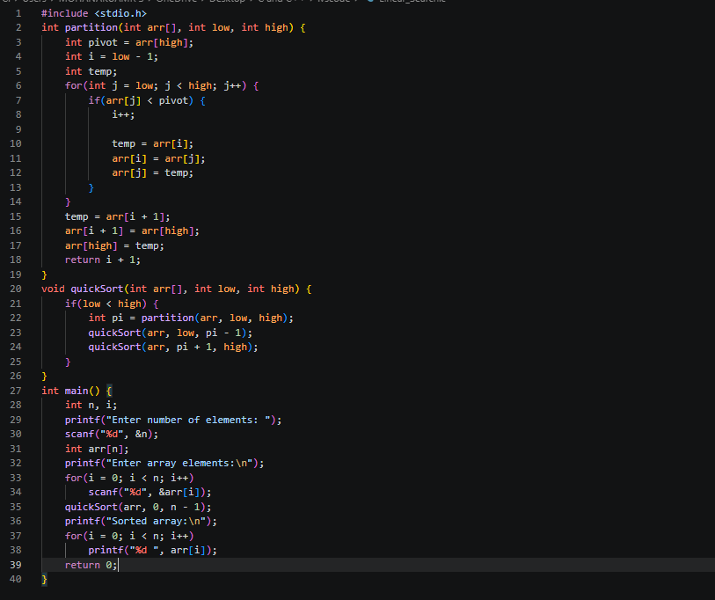
Output:
